**Kelp and the City: Urbanization and Climate Change Jointly Drive Decreases in Giant Kelp Forests Across Large Spatial Scales**

Isaac Rosenthal1, Jarrett E. K. Byrnes2,   
*1School for the Environment, University of Massachusetts Boston, 2Department of Biology, University of Massachusetts Boston*

**Summary paragraph**

Giant kelp (*Macrocystis pyrifera*) forests are critical marine habitats with great economic (Costanza et al., 2014; Cuba et al., 2022) and environmental value (Foster et al., 1985; Steneck & Erlandson, 2002). These forests are primarily found in temperate coastal waters and are sensitive to climate change (Cavanaugh et al., 2011; M. I. A. Tegner et al., 1996). This is not the only stressor that they experience; their distribution frequently overlaps with human population centers (Graham et al., 2007). Kelp is vulnerable to environmental disturbances associated with urbanization, especially water quality degradation as a result of sedimentation and/or eutrophication (Todd et al., 2019). It is possible that the impacts of temperature and urbanization are synergistic, but the potential synergies between these parameters have not been quantified. Here we show that coverage of impervious surface and temperature are both important predictors of kelp biomass, and that they may have nonlinear synergies. We used three decades of remote sensing data to causally model the relationship between kelp biomass and cover, sea surface temperature, and impervious surface coverage. We found that at medium (0.2) levels of impervious surface coverage, the expected correlation between temperature and kelp biomass breaks down, resulting in low biomass regardless of temperature. These results suggest that kelp forest responses to ocean warming are complex and attempts to forecast their response to climate change induced warming should include consideration of local anthropogenic impacts.

**Introduction**

Giant kelp (*Macrocystis pyrifera*) forests are an exceptionally valuable natural resource along many temperate coastlines of the world (DISTRIBUTION REFS). They provide key services such as wave dampening, nutrient cycling, fish and invertebrate habitat, tourism attraction, and goods supplied by direct harvest (Duggins et al., 1990; Elsmore et al., 2023; Gutierrez et al., 2006; Peteiro, 2018; Peters et al., 2019). ~~Globally, the services provided by kelp forests have an estimated annual value on the order of half-a-trillion dollars per year.~~ Giant kelp in North America provides an estimated $35 billion/year in services alone (Eger et al., 2023). These services rely on healthy kelp forests to realize their full potential (Smale et al., 2019). Kelp forests line the temperate coastlines of the world, where roughly 10% of humans live with a projected increase in human coastal population of up to 50% over the next 30 years (Neumann et al., 2015). As such, they are directly exposed to impacts of human coastal development. Urbanization in particular threatens to degrade water quality and the capacity for future provision of kelp-derived ecosystem services (Dwight et al., 2011; Gorman & Connell, 2009). Increasing coastal urbanization’s impact would occur against a backdrop of increasing climate change, which is already weakening the resilience of the world’s kelp forests (Steneck & Erlandson, 2002). Here we explore the joint consequences of coastal urbanization and climate change for giant kelp forests using 37 years of satellite-derived data from ~750km of California’s central and southern coast using Econometric causal modeling techniques to show how the two jointly act to reduce these vital ecosystems.

California’s coastal watersheds have experienced increases in urbanization of up to 30% over the last 70 years, with concomitant increases in runoff that could impact kelps (Beighley et al., 2003). Kelps require high light levels in cold nutrient rich water alongside low overgrowth by epiphytes or competition from encroaching fast-growing turf algae (Dayton, 1985; Schiel & Foster, 2015). Sediment and nutrient deposition due to elevated terrestrial runoff in urban environments with high impervious surface area stand to harm kelp forests on both of those fronts (Morris et al., 2020). Mechanistic studies of urbanization on subsurface kelp forests of *Ecklonia radiata* in South Australia show that urban runoff is a strong driver of kelp declines and replacement by turf algae (Gorman et al., 2009). *Macrocystis*, which forms dense high biomass surface canopies,is particularly vulnerable to both sedimentation and nutrient pollution in general (Connell, 2007). Sediment loading can directly limit recruitment of *Macrocystis*; early *Macrocystis* developmental stages are vulnerable to light limitation and sand-scour (Dayton, 1985; Tait, 2019). In extreme cases, sedimentation can lead to habitat loss as kelp cannot survive in areas without suitable amounts of hard substrate (Stephens et al., 2006). Nutrient runoff can similarly decrease kelp in natural populations. Increased turbidity can decrease light available for recruitment and growth of kelps and can favor algal turfs with low light requirements, shifting the balance of competition for space from kelp to turfs (F. E. Moy & Christie, 2012a). In addition, this turf-dominance effect is enhanced by increased sediment loads as a result of these turf’s morphologic capacity to trap sediments, allowing them to persist even under heavy sedimentation regimes (Airoldi, 1998). Thus, urbanization could potentially shift a kelp forest system to an alternate stable state due to its impacts on light and sediments.

Changes in light and sedimentation from accelerating coastal urbanization have not occurred in isolation. Climate change has led to a series of impacts that negatively affect kelp forests. These impacts include elevated temperatures, more frequent heat waves, changes in weather and ocean current patterns, alterations to predator/grazer dynamics, and warming-driven changes in competitive interactions with epiphytes and other algal species (Bennett et al., 2015; Filbee-Dexter & Scheibling, 2014; Frölicher & Laufkötter, 2018; Hayward, 1997; Provost et al., 2017; Scheibling & Gagnon, 2009; Smale, 2020; Vergés et al., 2014). Kelp loss in response to ocean warming and concomitant decreases in nutrients is a well-documented trend in marine ecosystems across the world (Beas-Luna et al., 2020; Dayton et al., 1998; Edyvane, 2003; Ling et al., 2009; McPherson et al., 2021; Pessarrodona et al., 2018). Urbanization and temperature could act as synergistic stressors in two ways. First, the strength of one could depend on the other – i.e., the per capita effect of sedimentation could be stronger under a warmer, low nutrient regime. Alternatively, one stressor could change the baseline on which the other acts. This change in baseline could make the impact of the second appear small merely due to there not being much kelp left to begin with – i.e. a 20% reduction of 20% of a forest is much smaller than a 20% reduction of 100% of a forest). Mechanistically, these synergies could be due to climate change reducing the resilience of *Macrocystis* via more frequent thermal stress and nutrient limitation (Cavanaugh et al., 2011).Urbanization alters the coastal hydrology by increasing terrestrial runoff, harming *Macrocystis* forestresilience to warming directly by depressing recruitment and growth (Tait, 2019). Hydrologic alterations associated with urbanization could also interact with climate change driven increases in storm frequency and intensity such that developed areas can experience higher levels of runoff-related pollution than pristine areas (Kaushal et al., 2008). These synergistic effects may be further amplified by the ecological consequences of environmental change related to these drivers; for example, the competitive dominance of turf-forming algae is enhanced under high nutrient/sediment conditions, and hysteresis may restrict the capacity for degraded kelp forests to recover (Filbee-Dexter et al., 2016; Filbee-Dexter & Wernberg, 2018).

In order to understand these possible joint influences of urbanization and ocean temperature change on kelp forests, we used data from multiple remote sensing sources to model the interaction between sea surface temperature (SST) and urban development on peak annual giant kelp biomass and cover in California. We included 11 sites in central and southern California, spanning from Point Reyes to the Mexican border. We modeled peak annual kelp biomass and aerial canopy cover from 1985-2021 as a function of several drivers: 1) spring SST, 2) summer SST, 3) percent cover of urban area, and 4) spring peak kelp biomass. By modeling both biomass per unit area and areal cover, we were able to tease apart how urbanization and climate change drive both the distribution and total amount of kelp in different areas along the West Coast of the US. We utilized causal modeling techniques drawn from the Econometrics literature (Antonakis et al., 2021; Butsic et al., 2017; Dudney et al., 2021; Mundlak, 1978; Pearl et al., 2016; Wooldridge, 2010) to control for confounding variables and show that, at large spatial scales, urbanization and warming work together to decrease kelp forest biomass and areal cover. Finally, our models used log of kelp biomass per unit area and a logistic curve of area covered (i.e., % of maximum forest area) to accommodate the nonlinear nature of the data, more cleanly evaluate synergies between drivers, and account for the possibility of nonlinear threshold effects.

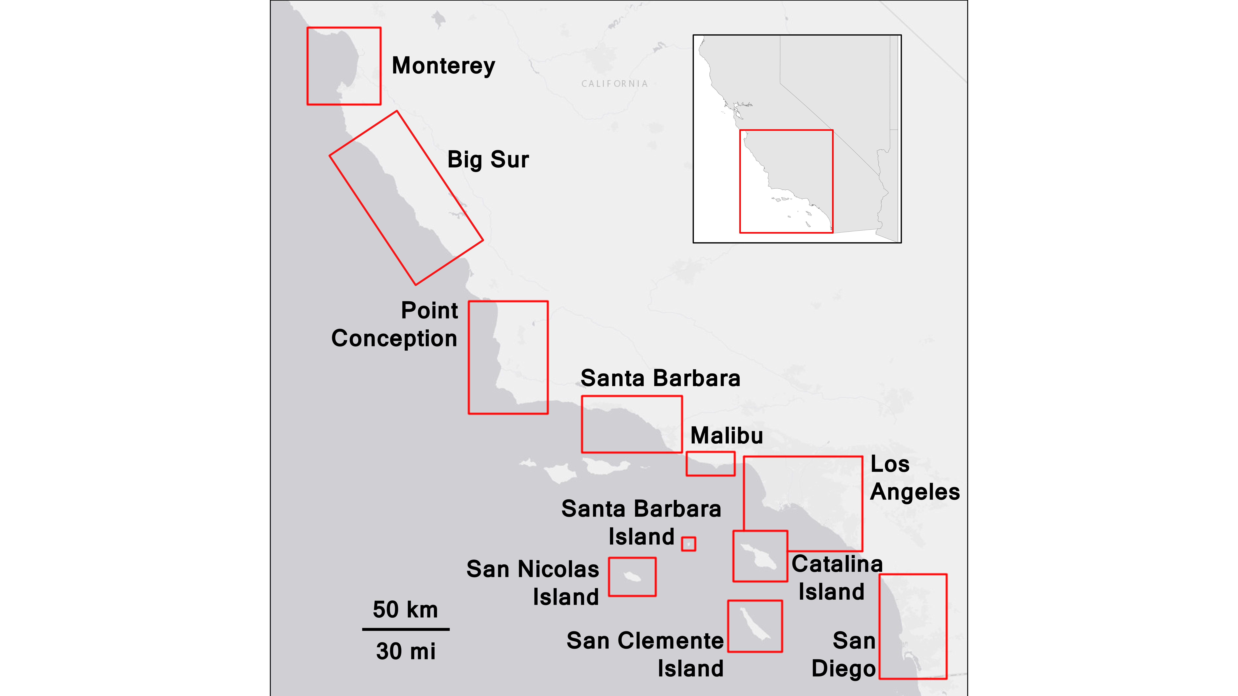

**Figure 1.** Map of sites used in our analysis, AOIs delineated in red. Inset depicts study region location relative to California’s coast. Basemap data sources: Esri, DeLorme, NAVTEQ

**Methods**

*Study sites and data sources*

The study sites used in our analysis consist of a series of segments along the California coast, spanning from Point Reyes to the Mexican border (Figure 1) We focused on this region in order to utilize the Landsat-derived Multiple Endmember Spectral Mixture Analysis (MESMA) database of kelp biomass and canopy cover (Bell et al., 2020, 2023; Hamilton et al., 2020). The data consists of quarterly measurements of kelp biomass derived from Landsat 5 Thematic Mapper (TM), Landsat 7 Enhanced Thematic Mapper Plus (ETM+), Landsat 8 Operational Land Imager (OLI), and Landsat 9 Operational Land Imager 2 (OLI-2) satellite imagery. USGS Level-2 Surface Reflectance images are first classified on a pixel-by-pixel basis into one of four categories (land, seawater, clouds/NA, and kelp) with a binary decision tree. The ratio of kelp to water for each “kelp” pixel is then modeled using multiple endmember spectral mixture analysis and converted to biomass by comparison to in situ diver surveys. See Bell et al. (2020) for thorough explanation and validation of this protocol. This dataset is curated and made available by the Santa Barbara Long Term Ecological Research site (SBC LTER), as well as being publicly available at <http://kelpwatch.org>. The data spans from 1984-the present, although we restricted our analysis to the years of 1985 to 2021 based on availability of ancillary data. For each site, we created a polygon area of interest (AOI), and for every quarter calculated an average biomass per pixel in order to correct for different sizes of available habitat at each site. For analyses of cover, we calculated quarterly percent cover as the fraction of pixels within a site’s area of interest that contained kelp in that given quarter divided by the number of pixels that have ever contained kelp at that site’s AOI.

We quantified urbanization using the USGS Land Change Monitoring, Assessment, and Protection (LCMAP) Collection 1.3 dataset (USGS, 2022). This data is derived via the application of a Continuous Change Detection and Classification (CCDC) algorithm to Landsat Analysis Ready Data (ARD) (Brown et al., 2020; Zhu & Woodcock, 2014). It provides an annual time series (1985-2021) of land cover classification at a 30-meter spatial resolution. This data was accessed via the USGS LCMAP viewer and downloaded as a series of georeferenced .tiff files. We calculated an “urbanization value” by quantifying the fraction of pixels in each of our sites’ AOIs that are classified as “Developed”. This approach to quantifying urban cover has been previously implemented in analyses of urbanization’s impact on freshwater ecosystems (Dietz & Clausen, 2008).

Temperature data was derived from NOAA’s Optimum Interpolation Sea Surface Temperature (OISST) ¼° dataset. OISST is a daily, continuously updated gridded temperature product with global coverage, beginning in 1981 (Huang et al., 2021). This data is derived from a variety of sources (primarily satellites, ships, and buoys). Satellite data is adjusted for bias based on in situ data (ships and buoys), and then missing grid cells are filled in using optimum interpolation. We accessed this data using R version 4.3.0 and the *rerddap* package (Chamberlain, 2023), which allows for direct, free data access given a user-provided bounding box, as well as start and end dates. We obtained data for each of our sites, calculated quarterly mean temperatures, and used both spring and summer average temperatures in our models.

*Causal Modeling approach*

All statistical analyses were performed in R version 4.3.0 (R Core Team, 2023). Models were fit using the *glmmTMB* package (Brooks et al., 2023). Our data is structured longitudinally as repeated measurements of the same pixels over time. Each individual measurement of kelp biomass is one pixel from a site *s* in a year *t.* To test for the impacts on biomass (“biomass model”), we used a generalized linear mixed model with a log-link to account for nonlinear change in our response variable. To test for impacts on cover (“cover model”), we used a beta regression with a logit-link, as the cover data is bounded between 0 and 1 (0-100% cover).

In order to estimate the causal relationship between kelp biomass and our predictors we utilized a Mundlak device model design from Econometrics (Mundlak, 1978). This approach is based on the assumption that there are confounding variables which influence our response that we did not measure or directly include as model parameters. These confounders are assumed to correlate with our parameters of interest at the site level. We account for them by calculating group means (i.e., site-mean terms in our analysis) and including them as parameters in our models. Because we implemented them in concert with a random effect of site, we can interpret our model results such that our predictors of interest describe the causal influence of those parameters on the response variable, with the influence of our confounders being captured by the group-mean coefficients - also called the contextual effect (Antonakis et al., 2021). The random effect of site then captures all remaining variation between sites that is not due to either our parameters of interest or confounders associated with them. In our case, the majority of these contextual effects were significantly different from 0 (Tables 1 & 2), implying that these confounders do have measurable impacts on our response and therefore controlling for them via the group mean approach was appropriate. To see how our model structure corresponds to a causal Directed Acyclic Graph of influences for which we do and do not have measurements, see Supp. Materials 2. To evaluate the robustness of our model to causal assumptions, we refit it with site as a fixed effect and no group level predictors (see Supplementary Materials 1) and found no differences in coefficient estimates. For more on these designs in an ecological context, see the appendix of Dee et al. (Dee et al., 2023) for a thorough explanation.

In addition to the site mean terms to control for confounders, our models included the following fixed effects: year as a categorical variable, spring mean biomass (or cover, for the cover model), summer mean water temperature, spring mean water temperature, and urbanization value (i.e., fraction of Landsat pixels classified as “developed”. In keeping with the group mean covariate approach, we included site-level means for spring and summer SST, spring kelp biomass (or cover), and urban percent cover as additional parameters in our model.

We also accounted for potential temporal heterogeneities in temperature’s impact on *Macrocystis* by including an interaction term between temperature and year; this is based on the assumption that although temperature is an important environmental parameter for *Macrocystis*, its impact will be modified by other oceanographic conditions that vary on an annual scale, such as winter storms (M. J. Tegner & Dayton, 1987).

We also included an interaction term between mean site-level urbanization values and mean site-level spring temperatures. This interaction term controls for possible interactions between unobserved confounding variables. In other words, the contextual effects of urbanization can depend on the contextual effect of temperature at that site, and this interaction term captures this possible relationship.

We assessed model assumptions with the *DHARMa* package (Hartig, 2023). The biomass model contains some potentially problematic intermediate residual values, but a visual inspection of a plot of observed vs simulated residuals confirmed the suitability of this model. The cover model fit well, with no issues. We used the *visreg* (Breheny & Burchett, 2023)and *ggeffects* (Lüdecke, 2023) packages to generate conditional predictions using our fitted models. Unless otherwise stated, these predictions were conditioned on the median values of our predictors.

**Results and Discussion**

Kelp at our sites spanned a range of biomass per unit area from 0.12 kg/m2 to 3892 kg/m2 (Ventura-Santa Barbara and Monterey, respectively). Overall, kelps have decreased by 76% in biomass and 11% in cover during the timeseries, although there is substantial interannual variability (Figure 2). Similarly, our sites span a range of thermal variation and human pressure over space and time. Urbanization values from nearly 0% to roughly 50% urban landcover (Figure 2), with San Nicolas Island (0.1%) and Los Angeles (54%) serving as the “pristine” and “heavily urbanized” ends of our urbanization axis. Suburbs and towns ranged from 1-20%. Over the course of the timeseries, the urbanization values at pristine sites were fairly stable: pristine sites were stable, changing by less than 0.5% (i.e., San Nicolas Island, Santa Barbara Island, Catalina Island, and Big Sur). However, more urbanized sites increased by as much as 5% across the time series (Los Angeles and San Diego). Ocean temperatures along the California coast are spatially variable, with oceanographic drivers such as coastal upwelling and the California Current System influencing local temperature regimes (Hickey, 1979; Huyer, 1983). The temperature at all sites increased over time ranging from 0.5 to 2 degrees celsius (Point Conception and Malibu, respectively, Figure 2). While there is substantial interannual variability that we attributed to a host of oceanographic factors (e.g., El Niño, The Blob), the long-term positive trend is attributed primarily to climate change (Mendelssohn et al., 2004).

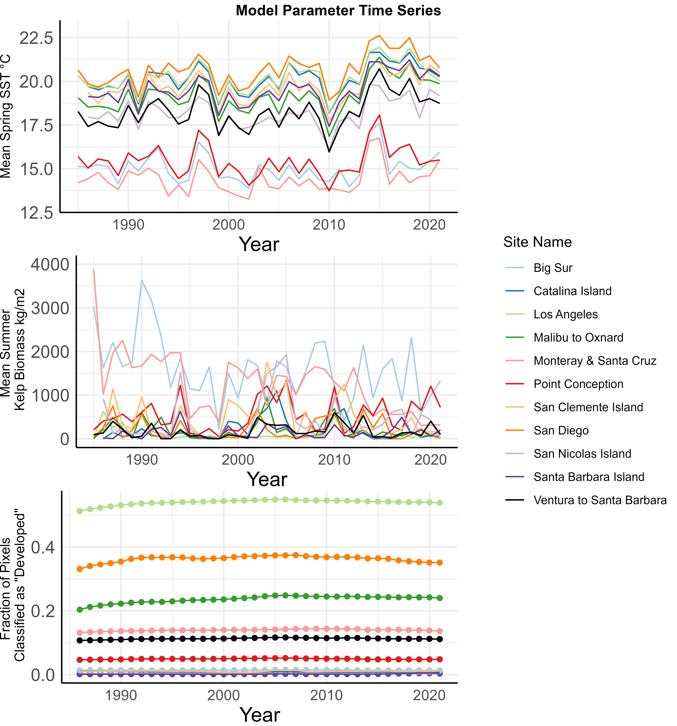

**Figure 2.** Time series of model parameters: A) Average summer kelp biomass over time in kg of wet kelp/meter2. B) Spring SST data for each site. C) Urban cover (fraction of pixels classified as “developed”) for each site.

Broadly, we find that urbanization reduces the biomass of kelp forests. It acts in synergy with rising ocean temperature, which similarly reduces the biomass of kelp forests, but also acts to shrink the area covered by kelp forests. Our model for biomass per unit area explained 71% of the variability in summer kelp biomass (Conditional R2: 0.713, Marginal R2: 0.697). Urbanization (beta = -35.56, SE= 12.71, p < 0.05, Fig. 2) has a negative impact on peak summer kelp biomass per unit area. This model result indicates that an area with an urban land cover of 100% (for reference, L.A. is 50%) would lack kelp. The impact of urbanization on kelp biomass becomes apparent quickly, with both our model and our data showing severe declines in areas with as low as 20% urban land cover (Fig. 2 showing predictions at median values of temperature in the data, 15.70º C). This means that urban areas have already lowered kelp biomass before experiencing thermal stress.

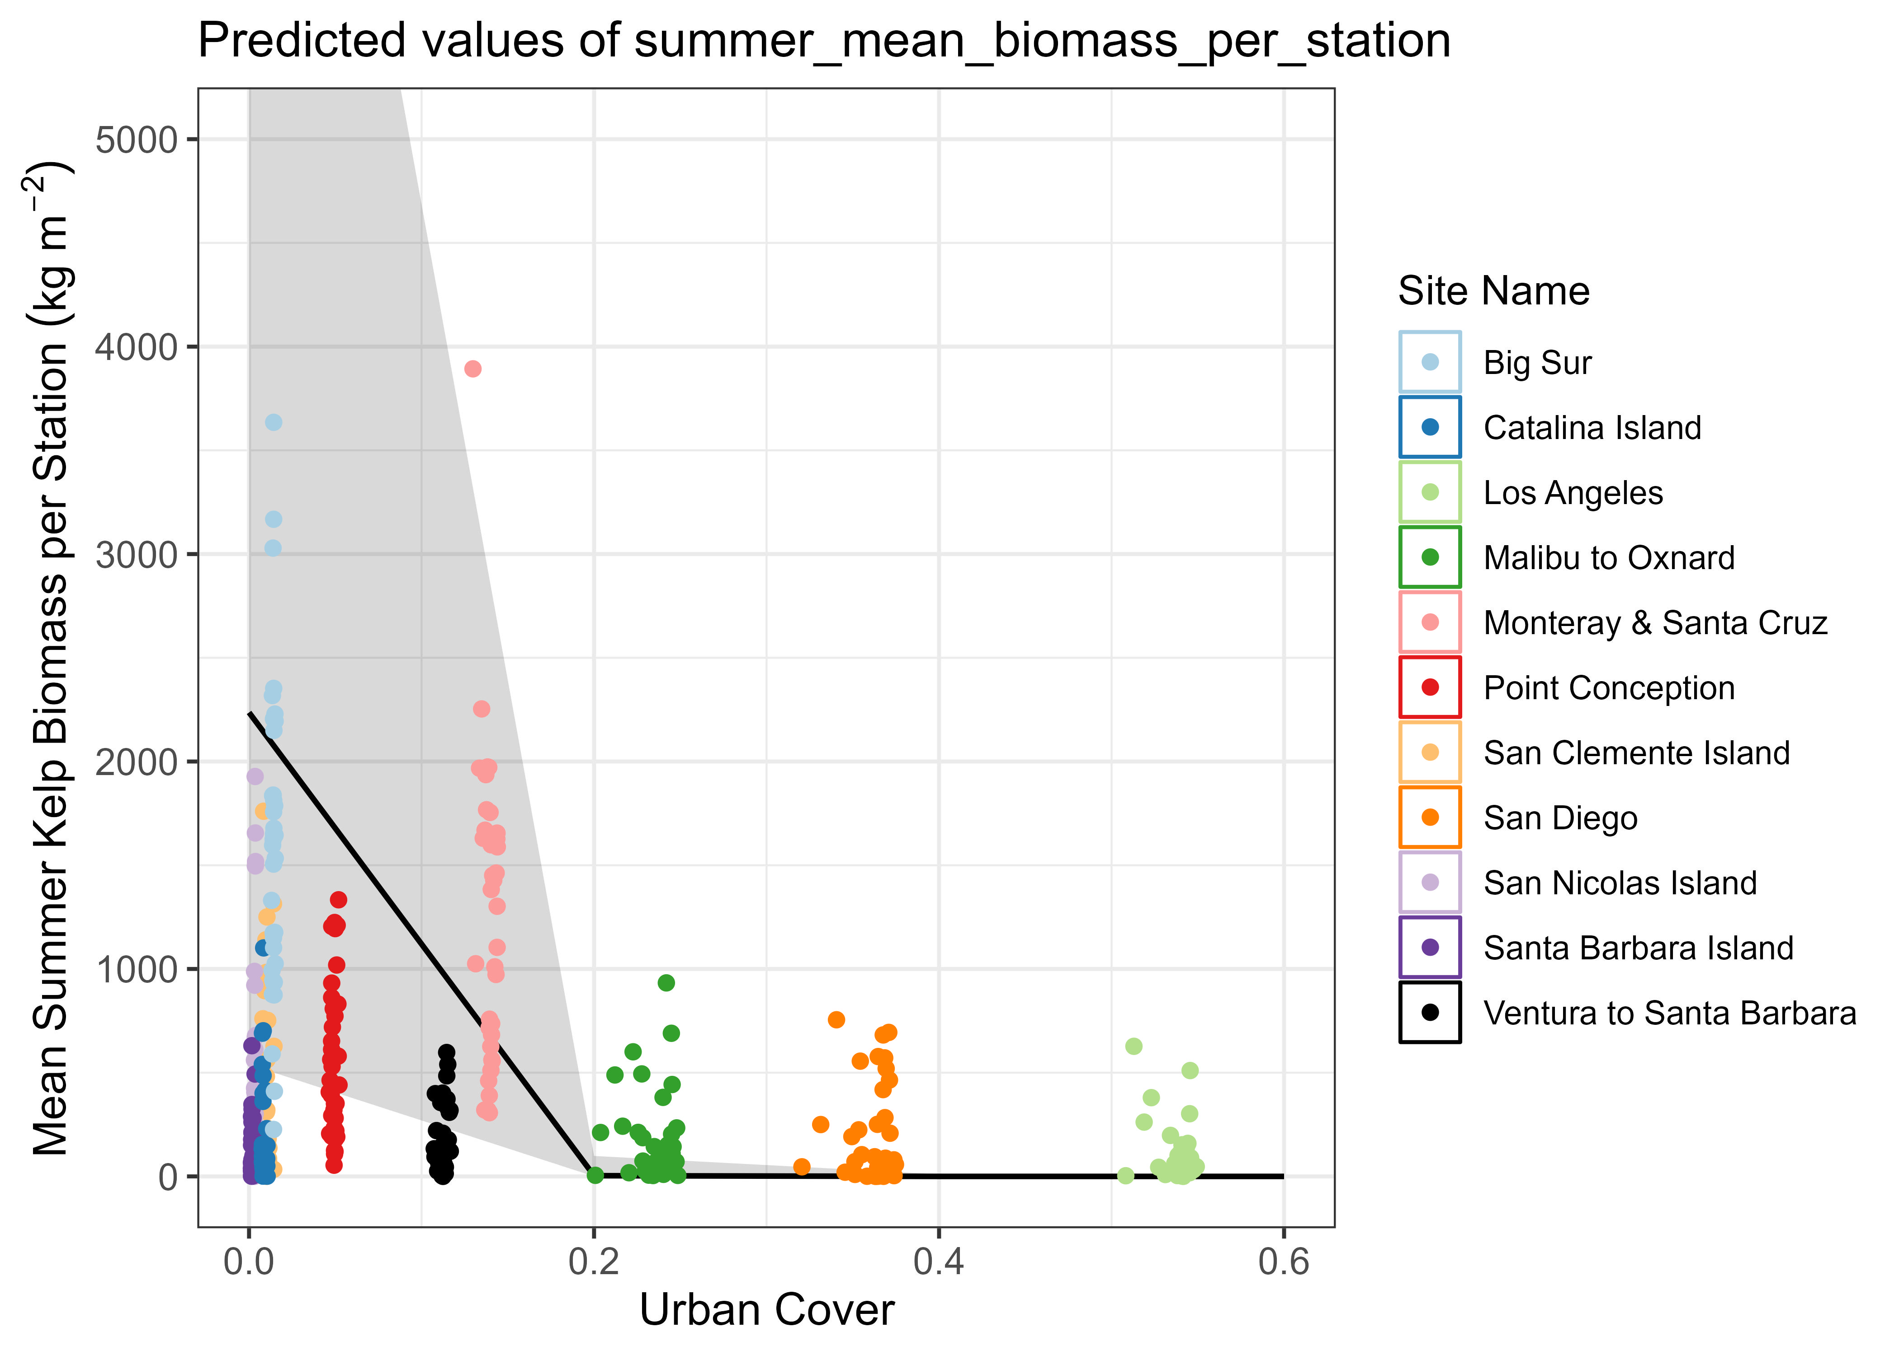

**Figure 3:** Model predicted values (black line) of mean summer biomass with 95% confidence intervals, conditional on median predictor values. Urban cover represents the fraction of pixels in a site that are classified as developed. Raw data (points) plotted for reference.

Spring temperature similarly had a negative relationship with summer kelp biomass but only as an interaction with year (p < 0.05), indicating temporal heterogeneity in kelp’s response to temperature due to other drivers that vary by year (e.g., storm disturbances, disease outbreaks, etc.) (Dayton et al., 1999; Dayton & Tegner, 1984; Tegner et al., n.d.; Vásquez et al., 2008; Wei et al., 2021). Despite this interannual heterogeneity, the overall impact of warming temperatures on kelp biomass is, like urbanization, negative (Figure 4). On average, warmer springs led to significantly reduced peak summer-kelp biomass than colder springs (Average beta = -4.3, average SE = 4.04). Curiously, there was no interaction between temperature and urbanization (p = 0.66). This is due to the nonlinear nature of the model - a decrease in kelp from urbanization means that temperature’s effects will occur on an already diminished kelp forest. Thus the effects of multiple stressors are cumulative, but the magnitude of one does not change due to the effects of the other.

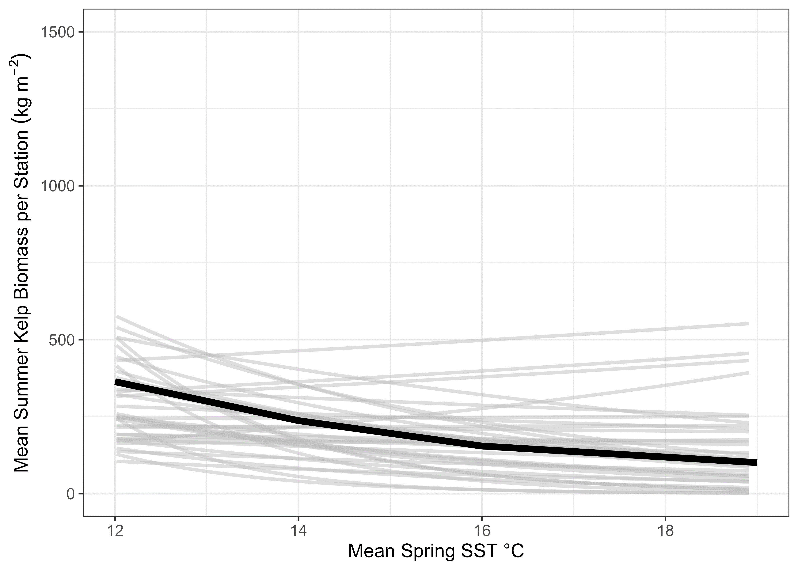

Fig 4. Interaction between mean spring SST and year. Lines display the effect of spring SST on summer kelp biomass for each year, conditional on the median values of all other predictors.

We controlled for several factors in our model to derive a causal estimate of the effects of urbanization and temperature. More kelp in the springtime was associated with more summer kelp biomass (β = 5.343e-01, p < 0.05). This was expected given that kelp recruits typically settle in late winter to early spring and begin to grow rapidly throughout the spring (Reed et al., 1988). We controlled for drivers confounded with temperature (both spring and summer) and urbanization by including parameters in our model that represent the mean temperature and urbanization values at each site, across the whole time series. These site means control for the influence of unmeasured variables that are correlated with temperature or urbanization and would otherwise confound our results. We found that there were significant confounders related to both spring (beta = -2.238. SE= 0.5991, p < 0.05) and summer (beta = -1.780, SE= 0.4575, p < 0.05) site means were significant. In addition, the site mean parameter for urbanization was significant (beta =14.23. SE= 16.55, p < 0.05). Finally, we included an interaction effect between site man spring temperatures and site mean urbanization to account for the possibility that these unmeasured variables can interact with each other and cause potentially nonlinear biases, although this parameter was not different from 0 (p = 0.19) These results suggest that there are indeed confounding variables that influence summer kelp biomass, but they do not interact with each other. Had we failed to account for them with our model, these omitted variables would bias our results and reduce our capacity for causal inference.

While urbanization and temperature decrease the biomass per unit area of kelp forests, we found that in contrast only temperature - and summer temperature at that - controls the total area of giant kelp forests. Mean summer temperatures influenced percent of area occupied by kelp (beta = -0.30669, p < 0.05, Fig. 4). Summer water temperature can have a strong effect on where kelp can survive - an increase of 1 degree celsius is associated with a 26% decrease in kelp canopy area (Figure 5). Additionally, this effect manifests as a nonlinear decline. Kelp persists across the entire range of summer temperature values we observed (14-22 degrees C), but at temperatures above 18 degrees C we see notable reductions in area, and near-total loss occurs far more frequently (Fig. 5). This result suggests that summer temperatures (and by proxy nutrient availability) are the most important determinant of kelp forest distribution, with the impacts of urbanization and spring temperature acting as “sub-lethal” effects in the context of patch persistence.

We implemented the same measures of control as with the biomass model to allow for causal inference by including site mean terms. Spring kelp coverage was again positively related to summer kelp coverage (beta = 3.07870, SE = 0.253758, p < 0.05), an unsurprising result. Again, there were significant influences of confounders related to spring (beta = 2.224946, SE = 0.586630, p < 0.05) and summer (beta = -1.636121, SE = 0.450943, p < 0.05) site mean temperatures. The site mean of urbanization was unimportant in isolation (p = 0.54), but the interaction between site mean urbanization and spring temperature was (beta = 1.334874, SE = 0.658748, p < 0.05), indicating the presence of interactive effects between unmeasured variables. As with the biomass model above, the inclusion of these site mean parameters and interactions enable us to account for these effects when interpreting our results, thus we can use them to infer causality.

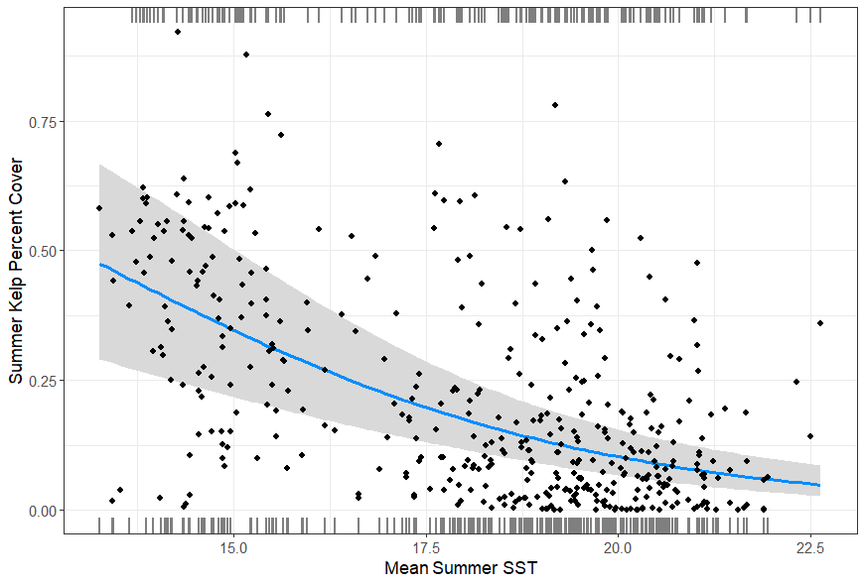

**Figure 5.** Model predicted values (blue line) of summer kelp percent cover, with 95% confidence intervals (grey) conditional on median predictor values. Raw data (points) plotted for reference.

Putting the results of both analyses together, we show that physical factors such as summer temperature establish the ceiling for total *Macrocystis* biomass within an area by driving distribution via availability of suitable habitat. Within this established distribution, kelp biomass per unit area is determined by both urbanization as well as spring temperatures. Our results indicate that urbanized kelp forests can be persistent but are likely to be sparse and characterized by smaller individuals with less canopy. However, the long-term persistence of these forests is not guaranteed in the face of warming ocean temperatures as a result of climate change.

Pulling back to consider the impact of global change on kelp forests, our results show that kelp forests are regulated by different drivers that set thresholds determining both forest distribution and biomass. While patches can be persistent (in terms of canopy coverage) across a range of summer temperatures from roughly 14 to 18 degrees C, above 18 degrees these patches see dramatic reductions in size (Fig. 5). Thus, temperature sets an upper bound for regional biomass. Simultaneously, kelp biomass per unit area is negatively influenced by both spring temperature and urbanization. The influence of spring temperature is variable based on annual conditions, but it is consistently negative. The influence of urbanization on summer kelp biomass is dramatic and indicates the presence of a sharp threshold of around 20% urbanization, at which point predicted biomass drops to near zero. Both act additively on a log-scale, thus one driver sets the upper bound of kelp biomass for the influence of the other. While this might look like an interaction, or synergy, on a linear scale (temperature does little at high levels of urbanization), this is an additive interaction on a log-scale. This is a subtle distinction from the perspective of management, however. Simply put, each driver can be viewed as resetting the threshold of maximum biomass for the other (Supplementary Figures 3 & 4).

While we focused on central and southern California, canopy forming kelps are critical ecosystem engineers across the globe and are threatened by environmental degradation across their entire distribution (Coleman et al., 2022; Connell, 2007; Dayton et al., 1998; Layton et al., 2020; Pfister et al., 2018). These effects are not limited to a specific canopy forming species. For example, bull kelp (*Nereocystis luetkeana*) is a canopy forming species that occurs in the northeast Pacific ocean and has seen massive losses over the last 150 years. Its extent has decreased by as much as 63%, with some areas experiencing almost complete loss, primarily attributed to changes in environmental conditions such as ocean temperature (Berry et al., 2021). Likewise, urbanization has been implicated in the decline of kelp in other regions as well; the metropolitan coast of Adeleide has lost up to 70% of its canopy forming kelps (Connell et al., 2008). Much of this loss is attributed to conversion from kelp forests to algal turfs, a process that is exacerbated by water quality degradation as a result of both urbanization as well as warming (Wernberg, 2021). Non-canopy forming kelps are also vulnerable to the combined impacts of urbanization and warming; sugar kelp (*Saccharina latissima*) in southern Norway has experienced significant loss and widespread conversion to algal turfs (F. E. Moy & Christie, 2012b). This loss is attributed to both increases in temperature as well as high levels of sedimentation and eutrophication, driven by runoff (Cossellu & Nordberg, 2010). Sites in this region have experienced conversion from rocky bottom to silt by as much as 35%, which has catastrophic implications for macroalgal recruitment (F. Moy et al., 2008). Despite these bleak examples, kelp populations have not exhibited a uniform global trend (Krumhansl et al., 2016); as of 2012 only 1/3 of ecoregions are dominated by declining forests. These examples and many others underscore the need to understand how kelps will respond to future environmental change such that management efforts can be effectively implemented, both in areas in need of remediation as well as areas that have not yet experienced loss (ref).

Overall, giant kelp forests near urban areas are more vulnerable to the negative impacts of climate change. Conversely, urbanization’s impact on kelp forests will only grow stronger in a warming ocean. Both of these findings are especially relevant to areas where kelp is already approaching its upper limit of thermal tolerance in the summer. Our results highlight the importance of considering thresholds of human impacts in kelp forest ecology and the ways in which human activities may synergize across multiple scales to threaten these key marine habitats. If we are to preserve kelp forest service provision, managers must account for synergy driven thresholds that could induce rapid ecosystem degradation (Hamilton et al., 2022). Understanding the nuances of how global and local drivers may interact to affect kelp distribution and health is a key part of this successful management as intensifying anthropogenic activity continues to challenge the resilience of these important ecosystems.

**References**

Airoldi, L. (1998). Roles of disturbance, sediment stress, and substratum retention on spatial dominance in algal turf. *Ecology*, *79*(8), 2759–2770.

Antonakis, J., Bastardoz, N., & Rönkkö, M. (2021). On Ignoring the Random Effects Assumption in Multilevel Models: Review, Critique, and Recommendations. *Organizational Research Methods*, *24*(2), 443–483. https://doi.org/10.1177/1094428119877457

Beas-Luna, R., Micheli, F., Woodson, C. B., Carr, M., Malone, D., Torre, J., Boch, C., Caselle, J. E., Edwards, M., Freiwald, J., Hamilton, S. L., Hernandez, A., Konar, B., Kroeker, K. J., Lorda, J., Montaño-Moctezuma, G., & Torres-Moye, G. (2020). Geographic variation in responses of kelp forest communities of the California Current to recent climatic changes. *Global Change Biology*, *26*(11), 6457–6473. https://doi.org/10.1111/gcb.15273

Beighley, R. E., Melack, J. M., & Dunne, T. (2003). Impacts of California’s Climatic Regimes and Coastal Land Use Change on Streamflow Characteristics. *JAWRA Journal of the American Water Resources Association*, *39*(6), 1419–1433.

Bell, T. W., Allen, J. G., Cavanaugh, K. C., & Siegel, D. A. (2020). Three decades of variability in California’s giant kelp forests from the Landsat satellites. *Remote Sensing of Environment*, *238*. https://doi.org/10.1016/j.rse.2018.06.039

Bell, T. W., Cavanaugh, K. C., & Siegel, D. A. (2023). *SBC LTER: Time Series of Quarterly NetCDF Files of Kelp Biomass in the Canopy from Landsat 5, 7 and 8, Since 1984 (Ongoing) Ver. 21.* Environmental Data Initiative.

Bennett, S., Wernberg, T., Harvey, E. S., Santana‐Garcon, J., & Saunders, B. J. (2015). Tropical herbivores provide resilience to a climate‐mediated phase shift on temperate reefs. *Ecology Letters*, *18*(7), 714–723.

Berry, H. D., Mumford, T. F., Christiaen, B., Dowty, P., Calloway, M., Ferrier, L., Grossman, E. E., & VanArendonk, N. R. (2021). Long-term changes in kelp forests in an inner basin of the Salish Sea. *PLoS ONE*, *16*(2 February). https://doi.org/10.1371/journal.pone.0229703

Breheny, P., & Burchett, W. (2023). *visreg: Visualization of Regression Models*. http://pbreheny.github.io/visreg

Brooks, M. E., Kristensen, K., van Benthem, K. J., Magnusson, A., Berg, C. W., Nielsen, A., Skaug, H. J., Maechler, M., & Bolker, B. M. (2023). glmmTMB Balances Speed and Flexibility Among Packages for Zero-inflate d Generalized Linear Mixed Modeling. In *The R Journal* (Issue 2). https://doi.org/10.32614/RJ-2017-066

Brown, J. F., Tollerud, H. J., Barber, C. P., Zhou, Q., Dwyer, J. L., Vogelmann, J. E., Loveland, T. R., Woodcock, C. E., Stehman, S. V., Zhu, Z., Pengra, B. W., Smith, K., Horton, J. A., Xian, G., Auch, R. F., Sohl, T. L., Sayler, K. L., Gallant, A. L., Zelenak, D., … Rover, J. (2020). Lessons learned implementing an operational continuous United States national land change monitoring capability: The Land Change Monitoring, Assessment, and Projection (LCMAP) approach. *Remote Sensing of Environment*, *238*. https://doi.org/10.1016/j.rse.2019.111356

Butsic, V., Lewis, D. J., Radeloff, V. C., Baumann, M., & Kuemmerle, T. (2017). Quasi-experimental methods enable stronger inferences from observational data in ecology. In *Basic and Applied Ecology* (Vol. 19, pp. 1–10). Elsevier GmbH. https://doi.org/10.1016/j.baae.2017.01.005

Cavanaugh, K. C., Siegel, D. A., Reed, D. C., & Dennison, P. E. (2011). Environmental controls of giant-kelp biomass in the Santa Barbara Channel, California. *Marine Ecology Progress Series*, *429*, 1–17. https://doi.org/10.3354/meps09141

Chamberlain, S. (2023). *rerddap: General Purpose Client for ERDDAP Servers*. https://CRAN.R-project.org/package=rerddap

Coleman, M. A., Reddy, M., Nimbs, M. J., Marshell, A., Al-Ghassani, S. A., Bolton, J. J., Jupp, B. P., De Clerck, O., Leliaert, F., Champion, C., Pearson, G. A., Serrão, E. A., Madeira, P., & Wernberg, T. (2022). Loss of a globally unique kelp forest from Oman. *Scientific Reports*, *12*(1). https://doi.org/10.1038/s41598-022-08264-3

Connell, S. D. (2007). Water Quality and the Loss of Coral Reefs and Kelp Forests: Alternative States and the Influence of Fishing. In S. D. Connell & B. M. Gillanders (Eds.), *Marine Ecology* (pp. 556–568).

Connell, S. D., Russell, B. D., Turner, D. J., Shepherd, S. A., Kildea, T., Miller, D., Airoldi, L., & Cheshire, A. (2008). Recovering a lost baseline: Missing kelp forests from a metropolitan coast. *Marine Ecology Progress Series*, *360*, 63–72. https://doi.org/10.3354/meps07526

Cossellu, M., & Nordberg, K. (2010). Recent environmental changes and filamentous algal mats in shallow bays on the Swedish west coast — A result of climate change? *Journal of Sea Research*, *63*, 202–212. https://doi.org/10.1016/j.seares.2010.01.004

Costanza, R., de Groot, R., Sutton, P., van der Ploeg, S., Anderson, S. J., Kubiszewski, I., Farber, S., & Turner, R. K. (2014). Changes in the global value of ecosystem services. *Global Environmental Change*, *26*(1), 152–158. https://doi.org/10.1016/j.gloenvcha.2014.04.002

Cuba, D., Guardia-Luzon, K., Cevallos, B., Ramos-Larico, S., Neira, E., Pons, A., & Avila-Peltroche, J. (2022). Ecosystem Services Provided by Kelp Forests of the Humboldt Current System: A Comprehensive Review. *Coasts*, *2*(4), 259–277. https://doi.org/10.3390/coasts2040013

Dayton, P. K. (1985). *Ecology of Kelp Communities*. *16*(1985), 215–245.

Dayton, P. K., & Tegner, M. J. (1984). Catastrophic storms, El Niño, and patch stability in a southern California kelp community. *Science*, *224*(4646), 283–285.

Dayton, P. K., Tegner, M. J., Edwards, P. B., & Riser, K. L. (1998). Sliding Baselines, Ghosts, and Reduced Expectations in Kelp Forest Communities. *Ecological Applications*, *8*(2), 309–322.

Dayton, P. K., Tegner, M. J., Edwards, P. B., & Riser, K. L. (1999). Temporal and spatial scales of kelp demography: The role of oceanographic climate. *Ecological Monographs*, *69*(2), 219–250. https://doi.org/10.1890/0012-9615(1999)069[0219:TASSOK]2.0.CO;2

Dee, L. E., Ferraro, P. J., Severen, C. N., Kimmel, K. A., Borer, E. T., Byrnes, J. E. K., Clark, A. T., Hautier, Y., Hector, A., Raynaud, X., Reich, P. B., Wright, A. J., Arnillas, C. A., Davies, K. F., MacDougall, A., Mori, A. S., Smith, M. D., Adler, P. B., Bakker, J. D., … Loreau, M. (2023). Clarifying the effect of biodiversity on productivity in natural ecosystems with longitudinal data and methods for causal inference. *Nature Communications*, *14*(1). https://doi.org/10.1038/s41467-023-37194-5

Dietz, M. E., & Clausen, J. C. (2008). Stormwater runoff and export changes with development in a traditional and low impact subdivision. *Journal of Environmental Management*, *87*(4), 560–566.

Dudney, J., Willing, C. E., Das, A. J., Latimer, A. M., Nesmith, J. C. B., & Battles, J. J. (2021). Nonlinear shifts in infectious rust disease due to climate change. *Nature Communications*, *12*(1). https://doi.org/10.1038/s41467-021-25182-6

Duggins, D. O., Eckman, J. E., & Sewell, A. T. (1990). Ecology of understory kelp environments. II. Effects of kelps on recruitment of benthic invertebrates. *Journal of Experimental Marine Biology and Ecology*, *143*(1), 27–45. https://doi.org/https://doi.org/10.1016/0022-0981(90)90109-P

Dwight, R. H., Caplan, J. S., Brinks, M. V., Catlin, S. N., Buescher, G., & Semenza, J. C. (2011). Influence of Variable Precipitation on Coastal Water Quality in Southern California. *Water Environment Research*, *83*(12), 2121–2130. https://doi.org/10.2175/106143011x12928814444574

Edyvane, K. (2003). Conservation Monitoring and Recovery of Threatened Giant Kelp ( Macrocystis pyrifera ) Beds in Tasmania – Final Report part 1. *Department of Primary Industries, Water & Environment, Hobart*, *November*, 106–177.

Eger, A. M., Marzinelli, E. M., Beas-Luna, R., Blain, C. O., Blamey, L. K., Byrnes, J. E. K., Carnell, P. E., Choi, C. G., Hessing-Lewis, M., Kim, K. Y., Kumagai, N. H., Lorda, J., Moore, P., Nakamura, Y., Pérez-Matus, A., Pontier, O., Smale, D., Steinberg, P. D., & Vergés, A. (2023). The value of ecosystem services in global marine kelp forests. *Nature Communications*, *14*(1). https://doi.org/10.1038/s41467-023-37385-0

Elsmore, K., Nickols, K. J., Miller, L. P., Ford, T., Denny, M. W., & Gaylord, B. (2023). Wave damping by giant kelp, Macrocystis pyrifera. *Annals of Botany*, mcad094.

Filbee-Dexter, K., Feehan, C. J., & Scheibling, R. E. (2016). Large-scale degradation of a kelp ecosystem in an ocean warming hotspot. *Marine Ecology Progress Series*, *543*, 141–152. https://doi.org/10.3354/meps11554

Filbee-Dexter, K., & Scheibling, R. E. (2014). Sea urchin barrens as alternative stable states of collapsed kelp ecosystems. In *Marine Ecology Progress Series* (Vol. 495, pp. 1–25). https://doi.org/10.3354/meps10573

Filbee-Dexter, K., & Wernberg, T. (2018). Rise of Turfs: A New Battlefront for Globally Declining Kelp Forests. In *BioScience* (Vol. 68, Issue 2, pp. 64–76). Oxford University Press. https://doi.org/10.1093/biosci/bix147

Foster, M. S., Schiel, D. R., & (U.S.), N. C. E. T. (1985). *The Ecology of Giant Kelp Forests in California: A Community Profile*. U.S. Fish and Wildlife Service. https://books.google.com/books?id=7t0UzwEACAAJ

Fox, J., Weisberg, S., & Price, B. (2023). *car: Companion to Applied Regression*. https://CRAN.R-project.org/package=car

Frölicher, T. L., & Laufkötter, C. (2018). Emerging risks from marine heat waves. In *Nature Communications* (Vol. 9, Issue 1). Nature Publishing Group. https://doi.org/10.1038/s41467-018-03163-6

Gorman, D., & Connell, S. D. (2009). Recovering subtidal forests in human-dominated landscapes. *Journal of Applied Ecology*, *46*(6), 1258–1265. https://doi.org/10.1111/j.1365-2664.2009.01711.x

Gorman, D., Russell, B. D., & Connell, S. D. (2009). Land-to-sea connectivity: linking human-derived terrestrial subsidies to subtidal habitat change on open rocky coasts. *Ecological Applications*, *19*(5), 1114–1126. http://hdl.handle.net/2440/51173PERMISSIONShttp://esapubs.org/esapubs/copyright.htm

Graham, M. H., Vásquez, J. A., & Buschmann, A. H. (2007). Global Ecology of the Giant Kelp Macrocystis: From Ecotypes to Ecosystems. *Oceanography and Marine Biology: An Annual Review*, *45*, 39–88. http://search.ebscohost.com/login.aspx?direct=true&AuthType=ip,uid&db=aph&AN=J0E127208099411&site=ehost-live&scope=site

Gutierrez, A., Correa, T., Muñoz, V., Santibañez, A., Marcos, R., Cáceres, C., & Buschmann, A. H. (2006). Farming of the giant kelp macrocystis pyrifera in southern Chile for development of novel food products. *Journal of Applied Phycology*, *18*(3–5), 259–267. https://doi.org/10.1007/s10811-006-9025-y

Hamilton, S. L., Bell, T. W., Watson, J. R., Grorud‐Colvert, K. A., & Menge, B. A. (2020). Remote sensing: generation of long‐term kelp bed data sets for evaluation of impacts of climatic variation. *Ecology*, *101*(7), e03031.

Hamilton, S. L., Gleason, M. G., Godoy, N., Eddy, N., & Grorud-Colvert, K. (2022). Ecosystem-based management for kelp forest ecosystems. *Marine Policy*, *136*. https://doi.org/10.1016/j.marpol.2021.104919

Hartig, F. (2023). *DHARMa: Residual Diagnostics for Hierarchical (Multi-Level / Mixed) Re gression Models*. http://florianhartig.github.io/DHARMa/

Hayward, T. L. (1997). Pacific Ocean climate change: atmospheric forcing, ocean circulation and ecosystem response. *Trends in Ecology & Evolution*, *12*(4), 150–154. https://doi.org/https://doi.org/10.1016/S0169-5347(97)01002-1

Hickey, B. M. (1979). The California current system—hypotheses and facts. *Progress in Oceanography*, *8*(4), 191–279.

Huang, B., Liu, C., Banzon, V., Freeman, E., Graham, G., Hankins, B., Smith, T., & Zhang, H.-M. (2021). Improvements of the Daily Optimum Interpolation Sea Surface Temperature (DOISST) Version 2.1. *Journal of Climate*, *34*(8), 2923–2939. https://doi.org/10.1175/JCLI-D-20

Huyer, A. (1983). Coastal upwelling in the California current system. In *Progress in Oceanography* (Vol. 12, Issue 3, pp. 259–284). https://doi.org/10.1016/0079-6611(83)90010-1

Kaushal, S. S., Groffman, P. M., Band, L. E., Shields, C. A., Morgan, R. P., Palmer, M. A., Belt, K. T., Swan, C. M., Findlay, S. E. G., & Fisher, G. T. (2008). Interaction between Urbanization and Climate Variability Amplifies Watershed Nitrate Export in Maryland. *Environmental Science & Technology*, *42*(16), 5872–5878. https://doi.org/10.1021/es800264f

Krumhansl, K. A., Okamoto, D. K., Rassweiler, A., Novak, M., Bolton, J. J., Cavanaugh, K. C., Connell, S. D., Johnson, C. R., Konar, B., Ling, S. D., Micheli, F., Norderhaug, K. M., Pérez-Matus, A., Sousa-Pinto, I., Reed, D. C., Salomon, A. K., Shears, N. T., Wernberg, T., Anderson, R. J., … Byrnes, J. E. K. (2016). Global patterns of kelp forest change over the past half-century. *Proceedings of the National Academy of Sciences*, *113*(48), 13785–13790. https://doi.org/10.1073/pnas.1606102113

Layton, C., Coleman, M. A., Marzinelli, E. M., Steinberg, P. D., Swearer, S. E., Vergés, A., Wernberg, T., & Johnson, C. R. (2020). Kelp Forest Restoration in Australia. In *Frontiers in Marine Science* (Vol. 7). Frontiers Media S.A. https://doi.org/10.3389/fmars.2020.00074

Ling, S. D., Johnson, C. R., Frusher, S. D., & Ridgway, K. R. (2009). Overfishing reduces resilience of kelp beds to climate-driven catastrophic phase shift. *Proceedings of the National Academy of Sciences of the United States of America*, *106*(52), 22341–22345. https://doi.org/10.1073/pnas.0907529106

Lüdecke, D. (2023). *ggeffects: Create Tidy Data Frames of Marginal Effects for ggplot from  Model Outputs*. https://strengejacke.github.io/ggeffects/

McPherson, M. L., Finger, D. J. I., Houskeeper, H. F., Bell, T. W., Carr, M. H., Rogers-Bennett, L., & Kudela, R. M. (2021). Large-scale shift in the structure of a kelp forest ecosystem co-occurs with an epizootic and marine heatwave. *Communications Biology*, *4*(1). https://doi.org/10.1038/s42003-021-01827-6

Mendelssohn, R., Schwing, F. B., & Bograd, S. J. (2004). Nonstationary seasonality of upper ocean temperature in the California Current. *Journal of Geophysical Research: Oceans*, *109*(10). https://doi.org/10.1029/2004JC002330

Morris, R. L., Hale, R., Strain, E. M. A., Reeves, S. E., Vergés, A., Marzinelli, E. M., Layton, C., Shelamoff, V., Graham, T. D. J., Chevalier, M., & Swearer, S. E. (2020). Key Principles for Managing Recovery of Kelp Forests through Restoration. *BioScience*, *70*(8), 688–698. https://doi.org/10.1093/biosci/biaa058

Moy, F., Christie, H., Steen, H., Stålnacke, P., Aksnes, D., Alve, E., Aure, J., Bekkby, T., Fredriksen, S., & Gitmark, J. (2008). *Final report from the Sugar Kelp Project 2005-2008. SFT-rapport 1043/2008*. TA-2467/2008. NIVA reportn.

Moy, F. E., & Christie, H. (2012a). Large-scale shift from sugar kelp (Saccharina latissima) to ephemeral algae along the south and west coast of Norway. *Marine Biology Research*, *8*(4), 309–321. https://doi.org/10.1080/17451000.2011.637561

Moy, F. E., & Christie, H. (2012b). Large-scale shift from sugar kelp (Saccharina latissima) to ephemeral algae along the south and west coast of Norway. *Marine Biology Research*, *8*(4), 309–321.

Mundlak, Y. (1978). On the pooling of time series and cross section data. *Econometrica: Journal of the Econometric Society*, 69–85.

Neumann, B., Vafeidis, A. T., Zimmermann, J., & Nicholls, R. J. (2015). Future coastal population growth and exposure to sea-level rise and coastal flooding - A global assessment. *PLoS ONE*, *10*(3). https://doi.org/10.1371/journal.pone.0118571

Pearl, J., Glymour, M., & Jewell, N. P. (2016). *Causal inference in statistics: A primer*. John Wiley & Sons.

Pessarrodona, A., Moore, P. J., Sayer, M. D. J., & Smale, D. A. (2018). Carbon assimilation and transfer through kelp forests in the NE Atlantic is diminished under a warmer ocean climate. *Global Change Biology*, *24*(9), 4386–4398. https://doi.org/10.1111/gcb.14303

Peteiro, C. (2018). *Alginate Production from Marine Macroalgae, with Emphasis on Kelp Farming* (pp. 27–66). https://doi.org/10.1007/978-981-10-6910-9_2

Peters, J. R., Reed, D. C., & Burkepile, D. E. (2019). Climate and fishing drive regime shifts in consumer-mediated nutrient cycling in kelp forests. *Global Change Biology*, *25*(9), 3179–3192. https://doi.org/10.1111/gcb.14706

Pfister, C. A., Berry, H. D., & Mumford, T. (2018). The dynamics of Kelp Forests in the Northeast Pacific Ocean and the relationship with environmental drivers. *Journal of Ecology*, *106*(4), 1520–1533. https://doi.org/10.1111/1365-2745.12908

Provost, E. J., Kelaher, B. P., Dworjanyn, S. A., Russell, B. D., Connell, S. D., Ghedini, G., Gillanders, B. M., Figueira, W. I., & Coleman, M. A. (2017). Climate-driven disparities among ecological interactions threaten kelp forest persistence. *Global Change Biology*, *23*(1), 353–361. https://doi.org/10.1111/gcb.13414

Reed, D. C., Laur, D. R., & Ebeling, A. W. (1988). Variation in algal dispersal and recruitment: the importance of episodic events. *Ecological Monographs*, *58*(4), 321–335.

Scheibling, R. E., & Gagnon, P. (2009). Temperature-mediated outbreak dynamics of the invasive bryozoan Membranipora membranacea in Nova Scotian kelp beds. *Marine Ecology Progress Series*, *390*, 1–13. https://doi.org/10.3354/meps08207

Schiel, D. R., & Foster, M. S. (2015). The biology and ecology of giant kelp forests. In *The Biology and Ecology of Giant Kelp Forests*. https://doi.org/10.2216/5501br01

Smale, D. A. (2020). Impacts of ocean warming on kelp forest ecosystems. In *New Phytologist* (Vol. 225, Issue 4, pp. 1447–1454). Blackwell Publishing Ltd. https://doi.org/10.1111/nph.16107

Smale, D. A., Wernberg, T., Oliver, E. C. J., Thomsen, M., Harvey, B. P., Straub, S. C., Burrows, M. T., Alexander, L. V., Benthuysen, J. A., Donat, M. G., Feng, M., Hobday, A. J., Holbrook, N. J., Perkins-Kirkpatrick, S. E., Scannell, H. A., Sen Gupta, A., Payne, B. L., & Moore, P. J. (2019). Marine heatwaves threaten global biodiversity and the provision of ecosystem services. In *Nature Climate Change* (Vol. 9, Issue 4, pp. 306–312). Nature Publishing Group. https://doi.org/10.1038/s41558-019-0412-1

Steneck, R., & Erlandson, J. M. (2002). *Kelp Forest Ecosystems : Biodiversity , Stability , Resilience and Future*.

Stephens, J. S., Larson, R. J., & Pondella, D. J. (2006). Rocky reefs and kelp beds. In *The Ecology of Marine Fishes: California and Adjacent Waters* (pp. 227–252). University of California Press. https://doi.org/10.1525/california/9780520246539.003.0009

Tait, L. W. (2019). Giant kelp forests at critical light thresholds show compromised ecological resilience to environmental and biological drivers. *Estuarine, Coastal and Shelf Science*, *219*, 231–241. https://doi.org/10.1016/j.ecss.2019.02.026

R Core Team. (2023). *R: A Language and Environment for Statistical Computing*. R Foundation for Statistical Computing. https://www.R-project.org/

Tegner, M. I. A., Dayton, P., Eedwards, P., & Riser, K. (1996). Is there evidence for long-term climatic change in Southern California kelp forests? *California Cooperative Oceanic Fisheries Investigations Reports*, *37*.

Tegner, M. J., & Dayton, P. K. (1987). El Niño Effects on Southern California Kelp Forest Communities. *Advances in Ecological Research*, *17*(C), 243–279. https://doi.org/10.1016/S0065-2504(08)60247-0

Tegner’, M. J., Dayton, P. K., Edwards, P. B., & Riser, K. L. (n.d.). *Large-scale, low-frequency oceanographic effects on kelp forest succession: a tale of two cohorts* (Vol. 146).

Todd, P. A., Heery, E. C., Loke, L. H. L., Thurstan, R. H., Kotze, D. J., & Swan, C. (2019). Towards an urban marine ecology: characterizing the drivers, patterns and processes of marine ecosystems in coastal cities. *Oikos*, *128*(9), 1215–1242. https://doi.org/10.1111/oik.05946

U.S. Geological Survey (USGS). (2022). Land Change Monitoring, Assessment, and Projection (LCMAP) Collection 1.3 Science Products for the Conterminous United States. In *USGS data release*.

Vásquez, J. A., Vega, J. M. A., & Buschmann, A. H. (2008). Long term variability in the structure of kelp communities in northern Chile and the 1997–98 ENSO. In *Eighteenth International Seaweed Symposium* (pp. 279–293). Springer Netherlands. https://doi.org/10.1007/978-1-4020-5670-3_35

Vergés, A., Steinberg, P. D., Hay, M. E., Poore, A. G. B., Campbell, A. H., Ballesteros, E., Heck, K. L., Booth, D. J., Coleman, M. A., Feary, D. A., Figueira, W., Langlois, T., Marzinelli, E. M., Mizerek, T., Mumby, P. J., Nakamura, Y., Roughan, M., van Sebille, E., Gupta, A. Sen, … Wilson, S. K. (2014). The tropicalization of temperate marine ecosystems: Climate-mediated changes in herbivory and community phase shifts. *Proceedings of the Royal Society B: Biological Sciences*, *281*(1789). https://doi.org/10.1098/rspb.2014.0846

Wei, X., Li, K. Y., Kilpatrick, T., Wang, M., & Xie, S. P. (2021). Large-Scale Conditions for the Record-Setting Southern California Marine Heatwave of August 2018. *Geophysical Research Letters*, *48*(7). https://doi.org/10.1029/2020GL091803

Wernberg, T. (2021). Marine heatwave drives collapse of kelp forests in Western Australia. In *Ecosystem collapse and climate change* (pp. 325–343). Springer.

Wooldridge, J. M. (2010). *Econometric analysis of cross section and panel data*. MIT press.

Zhu, Z., & Woodcock, C. E. (2014). Continuous change detection and classification of land cover using all available Landsat data. *Remote Sensing of Environment*, *144*, 152–171. https://doi.org/10.1016/j.rse.2014.01.011

############################################################################

Tables

|  |  |  |  |  |  |
| --- | --- | --- | --- | --- | --- |
| **Parameter** | **Estimate** | **Std. Error** | **Chisq** | **Df** | **Pr(>Chisq)** |
| Urban Pixel Fraction | -3.56E+01 | 3.66E+00 | 8.8295 | 1 | 0.0029639 |
| Site Mean Urban Pixel Fraction | 1.42E+01 | 1.27E+01 | 7.5193 | 1 | 0.006104 |
| Mean Summer SST | -2.59E-01 | 1.66E+01 | 1.9263 | 1 | 0.1651659 |
| Site Mean Summer SST | -1.79E+00 | 1.87E-01 | 15.2225 | 1 | 9.56E-05 |
| Mean Spring SST | -5.95E-01 | 4.58E-01 | 0.97 | 1 | 0.3246749 |
| Site Mean Spring SST | 2.24E+00 | 3.60E-01 | 13.9348 | 1 | 0.0001893 |
| Mean Spring Kelp Biomass | 9.80E-04 | 5.99E-01 | 35.797 | 1 | 2.19E-09 |
| Site Mean Spring Kelp Biomass | 5.07E-04 | 1.64E-04 | 0.2826 | 1 | 0.5950214 |
| Year | -4.31E+00 | 4.04E+00 | 247.4188 | 36 | <2.2E-16 |
| Mean Spring SST*Year | 4.22E-01 | 2.89E-01 | 58.3082 | 36 | 0.010733 |
| Urban Pixel Fraction*Mean Spring SST | 2.01E-01 | 4.54E-01 | 0.1965 | 1 | 0.6575251 |
| Site Mean Urban Pixel Fraction*Site Mean Spring SST | 1.02E+00 | 7.73E-01 | 1.732 | 1 | 0.1881566 |

Table 1: Biomass model results. p-values represent the output of Type II Wald chisquare tests, implemented via the Anova() function in the car package for R version XXX. Coefficient estimates and standard errors for year and year*spring interaction term presented as mean values for clarity, as these categorical variables have 37 levels each.

|  |  |  |  |  |  |
| --- | --- | --- | --- | --- | --- |
| **Parameter** | **Estimate** | **Std. Error** | **Chisq** | **Df** | **Pr(>Chisq)** |
| Urban Pixel Fraction | -5.136441 | 9.181929 | 0.6608 1 | 1 | 0.4162818 |
| Site Mean Urban Pixel Fraction | -17.571096 | 12.973908 | 0.3623 | 1 | 0.5472069 |
| Mean Summer SST | -0.306694 | 0.057383 | 28.5657 | 1 | 9.06E-08 |
| Site Mean Summer SST | -1.636121 | 0.450943 | 13.164 | 1 | 0.0002854 |
| Mean Spring SST | -4.847213 | 3.853077 | 1.8303 | 1 | 0.1760877 |
| Site Mean Spring SST | 2.224946 | 0.58663 | 16.7639 | 1 | 4.23E-05 |
| Mean Spring Kelp Percent Cover | 3.078701 | 0.253758 | 147.1955 | 1 | < 2.2e-16 |
| Site Mean Spring Kelp Percent Cover | 3.705473 | 1.847168 | 4.0242 | 1 | 0.0448531 |
| Year | -0.016062 | 0.029101 | 24.3438 | 36 | 8.06E-07 |
| Mean Spring SST*Year | 0.002377 | 0.001926 | 1.5232 | 36 | 0.2171363 |
| Urban Pixel Fraction*Mean Spring SST | -0.041713 | 0.365793 | 0.013 | 1 | 0.9092098 |
| Site Mean Urban Pixel Fraction*Site Mean Spring SST | 1.334874 | 0.658748 | 4.1062 | 1 | 0.042726 |

Table 2:

Cover model results. p-values represent the output of Type II Wald chisquare tests, implemented via the Anova() function in the *car* package (Fox et al., 2023) for R version 4.3.0 (R Core Team, 2023). Coefficient estimates and standard errors for year and year*spring interaction term presented as mean values for clarity, as these categorical variables have 37 levels each.

Supplement 1

In order to evaluate the robustness of our model results to casual assumptions, we also fit a model that does not contain group level predictors, and includes site as a fixed effect. This model was fit using the *glmmTMB* package (Brooks et al., 2023) for R version 4.3.0 (R Core Team, 2023), and otherwise utilizes the same generalized linear mixed model framework as our group-mean biomass and cover models. Model parameters included urban cover, spring and summer mean temps, spring biomass, site, year, and two interaction terms: spring mean temperature* urban cover (to investigate the possibility of linear interaction terms) and spring mean temperature *year (to account for temporal heterogeneity in the effect of temperature). The results of this model corroborate the conclusions drawn from our group-means model. Urban pixel fraction (beta = -36.9, SE = 11.6, p < 0.05), the interaction between mean spring SST and year (average beta = 43.4, average SE = 3.83, p < 0.05), and spring biomass (beta =1.000e-03, SE = 1.498e-04, p < 0.05) are all significant predictors of summer kelp biomass (Supplementary table 1). This result supports the implementation of the group-mean approach to refine this analysis and enable causal inference.

|  |  |  |  |  |  |
| --- | --- | --- | --- | --- | --- |
| **Parameter** | **Estimate** | **Std. Error** | **Chisq** | **Df** | **Pr(>Chisq)** |
| Mean Summer SST | -2.38E-01 | 1.80E-01 | 1.622 | 1 | 0.202776 |
| Mean Spring SST | -6.34E-01 | 3.32E-01 | 1.142 | 1 | 0.28517 |
| Mean Spring Kelp Biomass | 1.00E-03 | 1.50E-04 | 37.123 | 1 | 1.11E-09 |
| Urban Pixel Fraction | -3.69E+01 | 1.16E+01 | 9.424 | 1 | 0.002142 |
| Site | 3.90E+00 | 1.83E+00 | 85.585 | 10 | 4.00E-14 |
| Year | -4.43E+00 | 3.83E+00 | 176.199 | 36 | <2.2E-16 |
| Mean Spring SST*Urban Pixel Fraction | 2.14E-01 | 4.02E-01 | 0.226 | 1 | 0.634545 |
| Mean Spring SST*Year | 4.34E-01 | 2.64E-01 | 58.807 | 36 | 0.00958 |

Supplementary table 1:

Fixed Effects model results. p-values represent the output of Type II Wald chisquare tests, implemented via the Anova() function in the car package (Fox et al., 2023) for R version 4.3.0 (R Core Team, 2023) . Coefficient estimates and standard errors for site, year and year*spring interaction term presented as mean values for clarity, as these categorical variables have 11 levels (site) and 37 (year terms).

Supplement 2

In order to assist with determining the structure of our causal model, we represented our variables of interest as a directed acyclic graph. For ease of interpretation, we did not graphically depict interaction effects, although they are assumed to be present and we structured our models as such. Variables in boxes denote measured variables, variables in ovals denote random effects. Arrows denote causal linkages between variables. Supplementary Figure 1 represents what our model structure would be if we fit only fixed effects and a random effect of site. Solid lines display the system assumed by fitting a mixed model with a random effect of site. However site is correlated with temperature, urbanization, and spring biomass (indicated with dotted lines, supplementary figure 1). These site level correlations represent the drivers that are associated with our measured variables (temp, spring biomass, and urbanization), but that vary on a site level – aka, the contextual effect of these parameters (Antonakis et al., 2021). In other words, these are ways in which site confounds our response variable by way of unmeasured variables that are related to our predictors, and would prevent us from making causal inferences with this model structure.

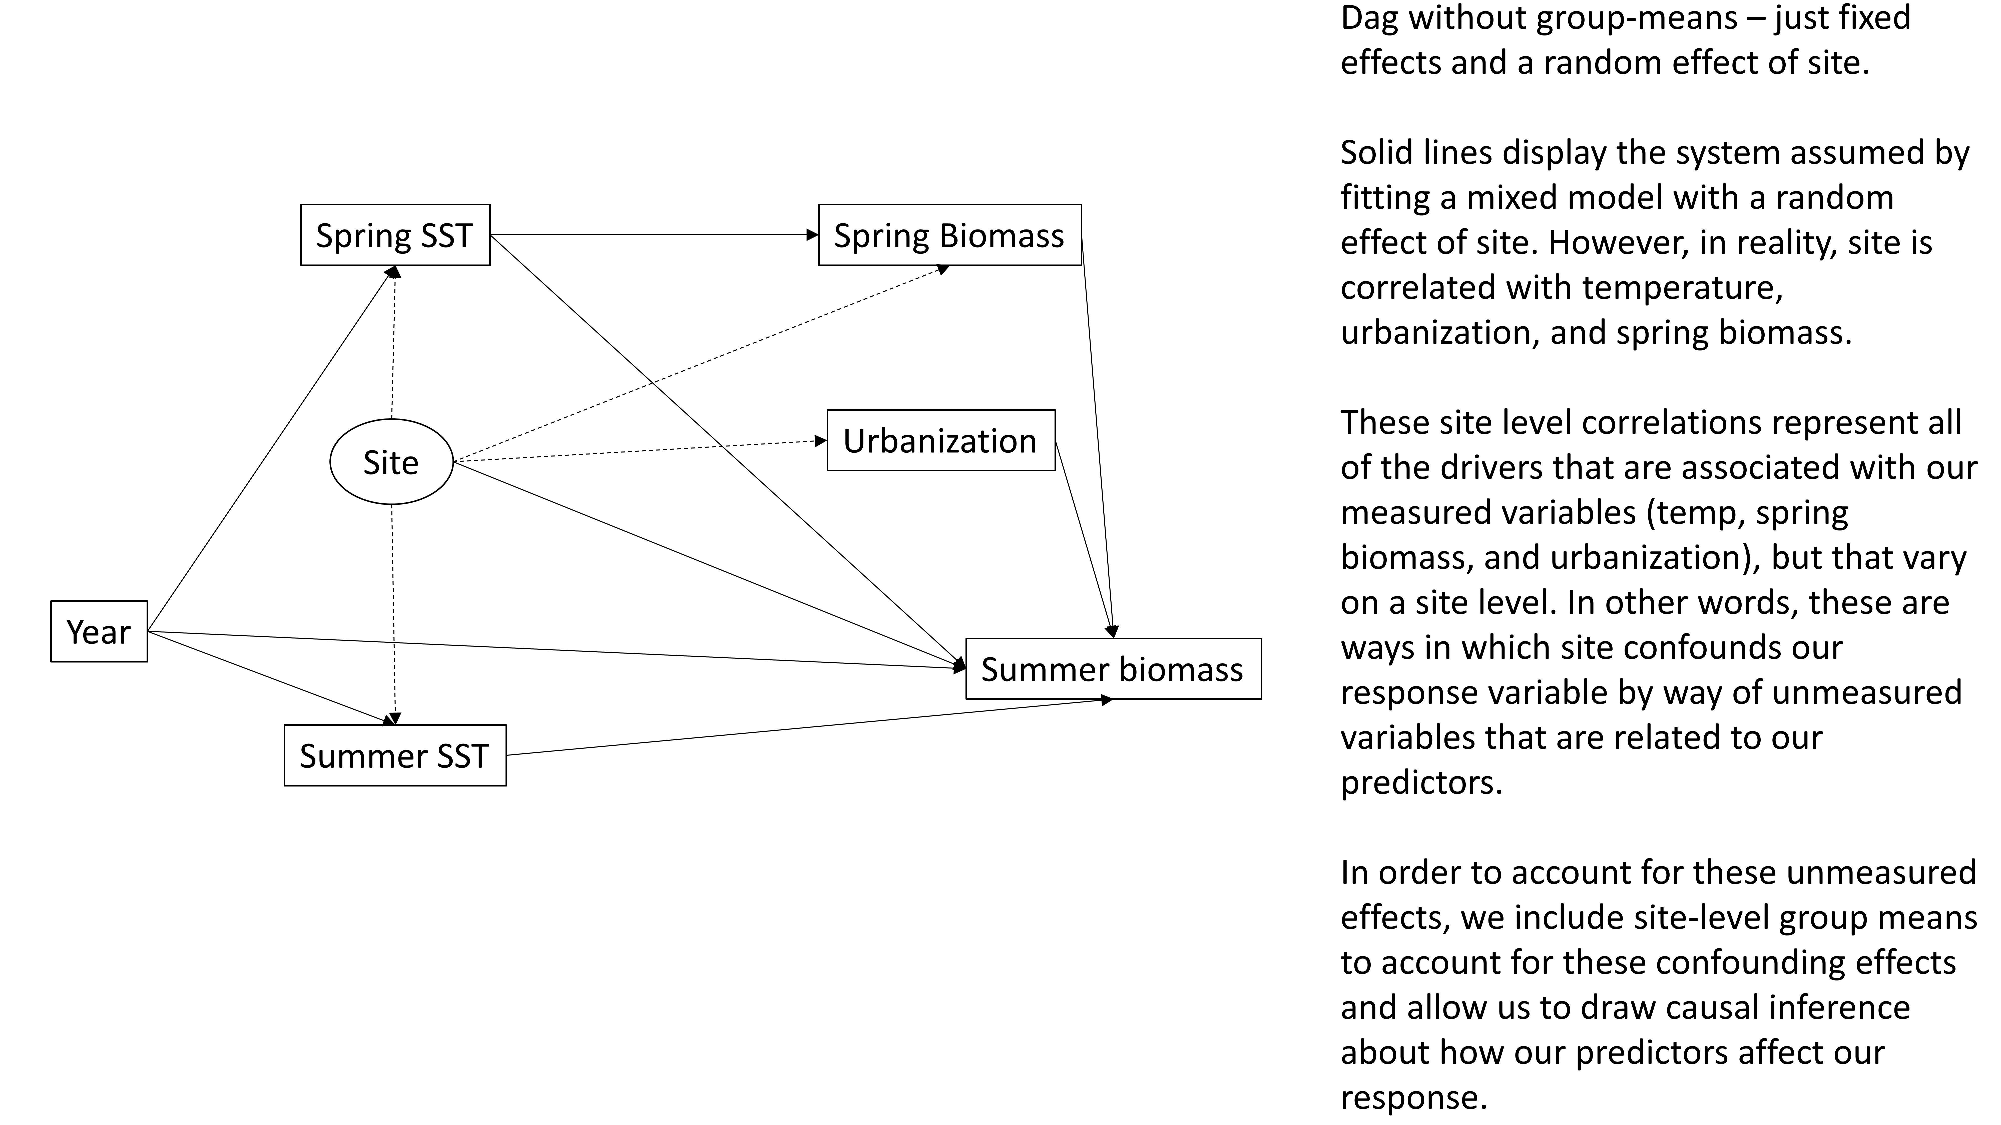

**Supplementary figure 1:** Directed Acyclic Graph denoting the model structure assumed when using a random effect. Measured variables are indicated by boxes, random effects are indicated by ovals. Solid arrows indicate associations codified in the model, dotted lines denote the actual relationships between variables. Interactions between variables not shown.

In order to account for these unmeasured effects, we include site-level group means to account for these confounding effects and allow us to draw causal inference about how our predictors affect our response. Once calculated, these variables are treated as any other model parameter. With these site-mean predictors, the random effect of site is no longer associated with any of our other predictors and thus satisfies the assumption that it is independent of our other variables (Supplementary figure 2). 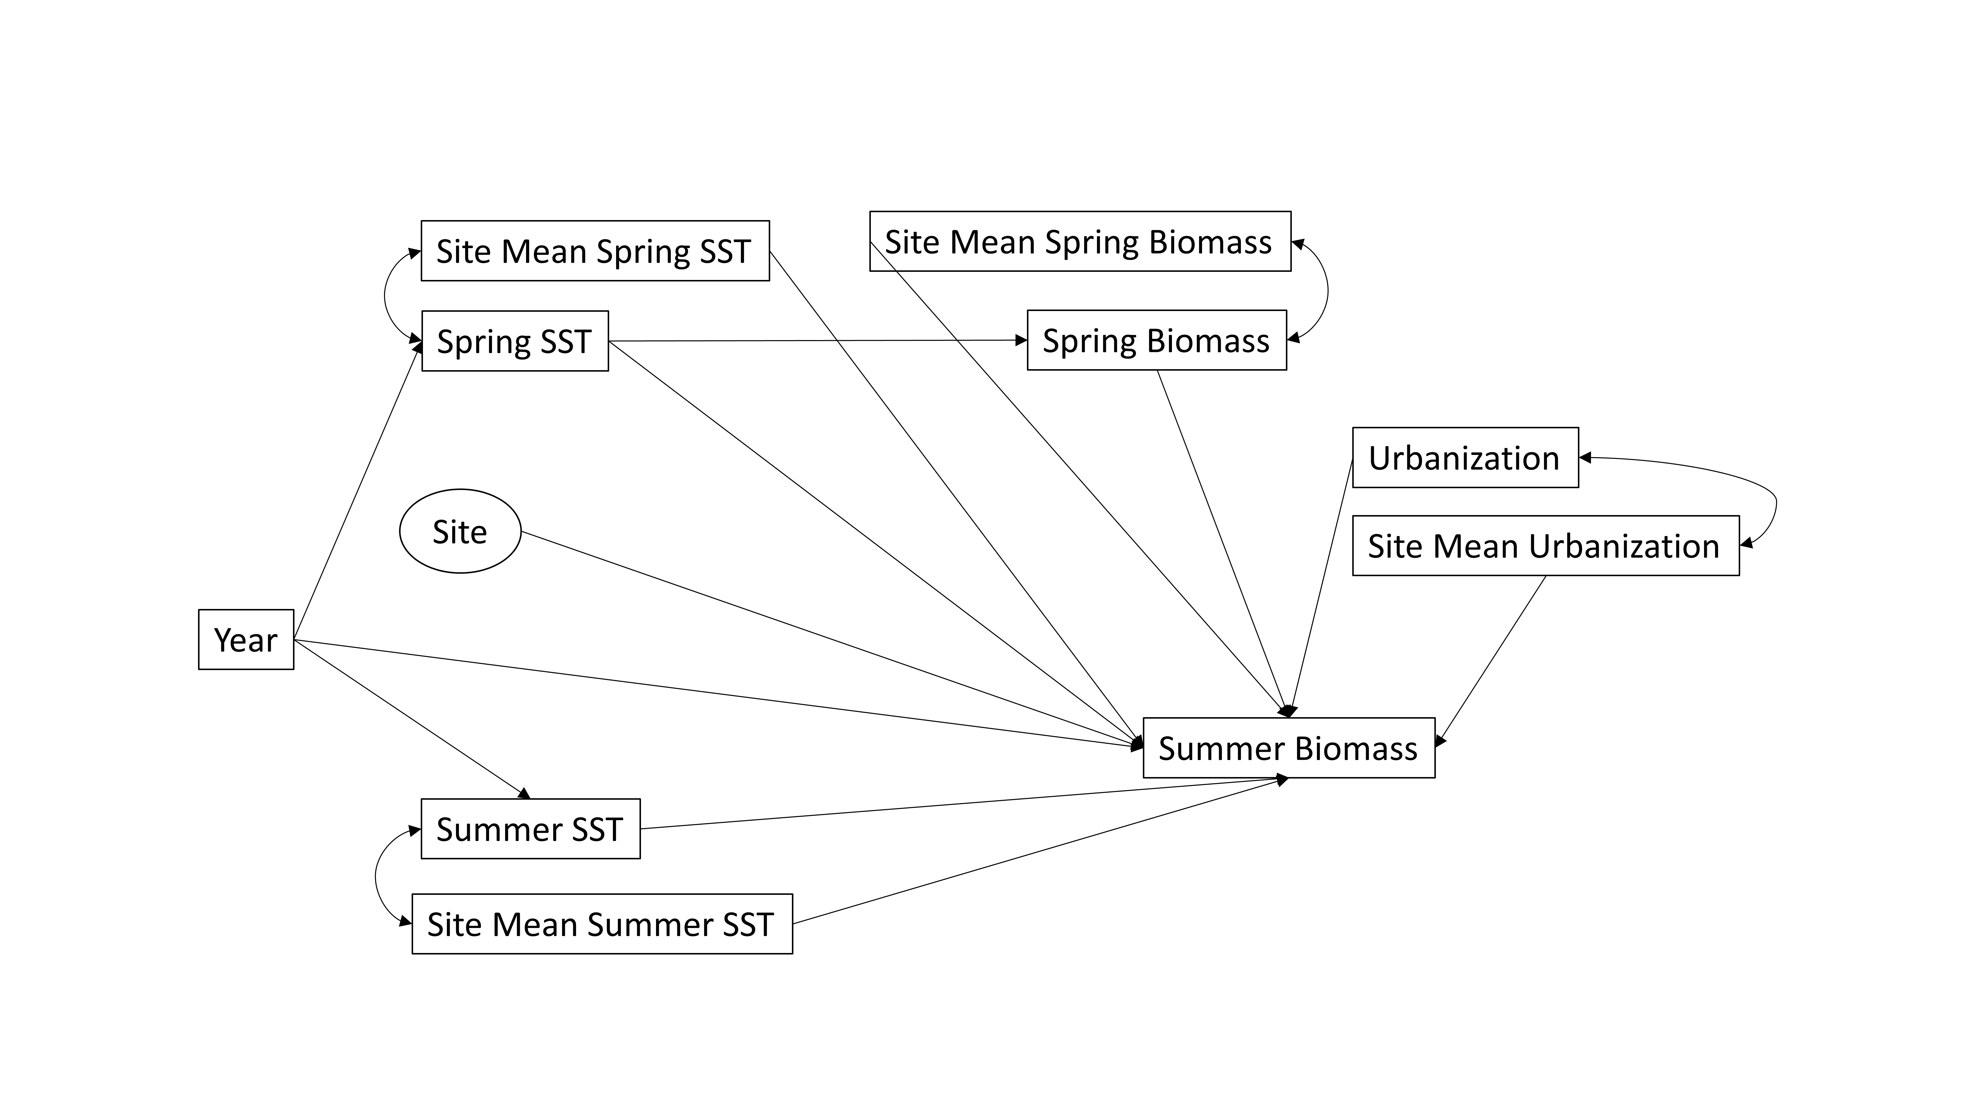

**Supplementary figure 2:** Directed Acyclic Graph denoting our model structure. Measured variables are indicated by boxes, random effects are indicated by ovals. Arrows indicate causal linkages. Interactions between variables not shown.

**Supplement 3**

To aid with understanding nonlinear synergies, consider the following conceptual example.

In this example, we are interested in how two stressors (e.g., temperature and urbanization) affect an environmental response (e.g., kelp biomass). In isolation, kelp biomass exhibits nonlinear responses to each of our environmental stressors independently (Supplementary figure 3). Points A1 and B1 represent kelp biomass under low values of these stressors (low stressed), and points A2 and B2 represent kelp biomass under elevated conditions (high stress). In the absence of a synergy, if one were interested in how kelp will respond to these stressors, one could simply use the model fit to estimate kelp biomass by using A2 or B2 to generate predictions of kelp biomass.

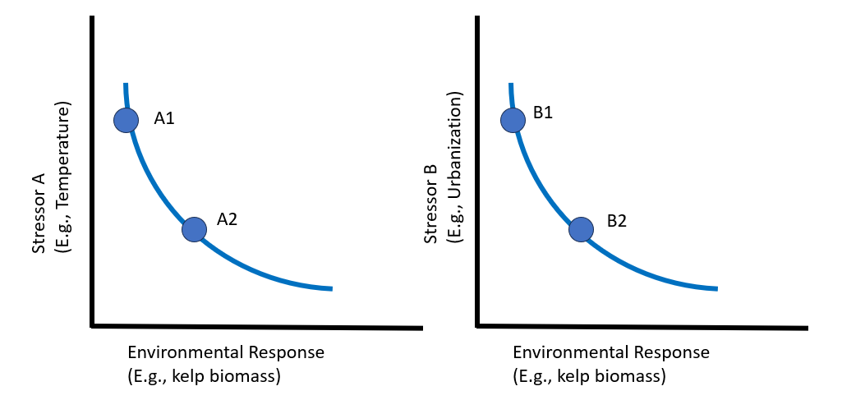

**Supplementary figure 3:** Conceptual diagram of non-linear kelp response to two non-synergistic stressors. Points A1 and B1 represent kelp biomass under low stress conditions, points A2 and B2 represent kelp biomass under high stress conditions.

However, if both occur in concert, one stressor can set the baseline for kelp biomass – the absolute maximum kelp that is possible under those conditions. This in turn influences the maximum impact that the other stressor can have on kelp biomass (Supplementary figure 4). The impacts of stressors A and B occurring together can drive kelp loss beyond what would normally occur under these conditions in a vacuum. Note that in reality these stressors are likely to be continuous variables, we have simply illustrated four possible combinations for simplicity. In addition, it may not always be clear which stressor sets the baseline. In general both natural history and relevant mechanisms in the ecosystem in question should be considered when applying this framework.

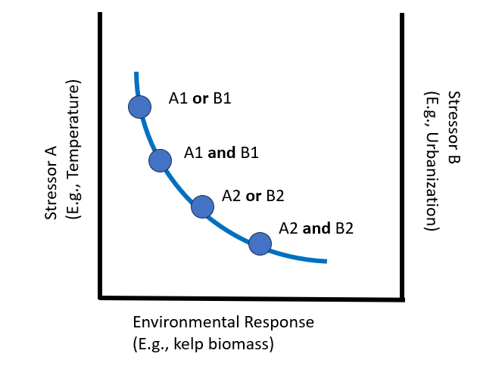

**Supplementary figure 4:** Conceptual diagram of non-linear kelp response to two synergistic stressors. Kelp biomass is reduced even in the low stress conditions, when both drivers are considered simultaneously. Under conditions of synergistic high stress, biomass is reduced beyond what either stressor is capable of in isolation.